Contact Dr. Kevin O’Mara, President
School Exec Connect
805 W. Lake Street, #301
Oak Park, IL 60301
(312) 780-1462

PRESS RELEASE

FOR IMMEDIATE RELEASE

School Exec Connect offering a free session to help minority educators attain superintendent positions.
Learn what’s involved from leaders who have successfully navigated the process

November 10, 2021: School Exec Connect, a national search and consulting firm focused on education, is holding a specialized session designed to help minority educators obtain their first superintendent position. This in-person session is being held on November 20, 2021 at 2 p.m. at the Loews Hotel located at 455 N. Park Avenue in Chicago.

Recognizing the need to encourage and develop educators from diverse backgrounds, School Exec Connect has enlisted four superintendents from across the Chicago metropolitan area to help participants understand and navigate the recruitment process - from application to interview.

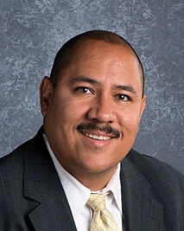  Dr. David Negron  Superintendent of School District 89 | Dr. Donna Simpson-Leak  Superintendent of Community Consolidated Schools District 168
Dr. Bhavna Sharma-Lewis  Superintendent of Diamond Lake 76 | Dr. Devon Horton  Superintendent of Evanston/Skokie District 65

School Exec Connect is offering this in-person session free of charge to help educators successfully advance in their careers. However, to ensure participants get the targeted support they need, space is limited to 30 participants, so register now.

School Exec Connect provides a wide range of educational services including searches for school executives, board development workshops, superintendent evaluation, strategic planning, communication assessments, mentoring, conflict resolution, and executive coaching for improving administrators’ skills. Visit us at schoolexecconnect.com.

